Practice Javascript the Regex - Correction

**Evaluated skills :**

*→ The regex lessons Part1 and Part2*

**Question 1 :** Write a JavaScript program to test the first character of a string is uppercase or not.

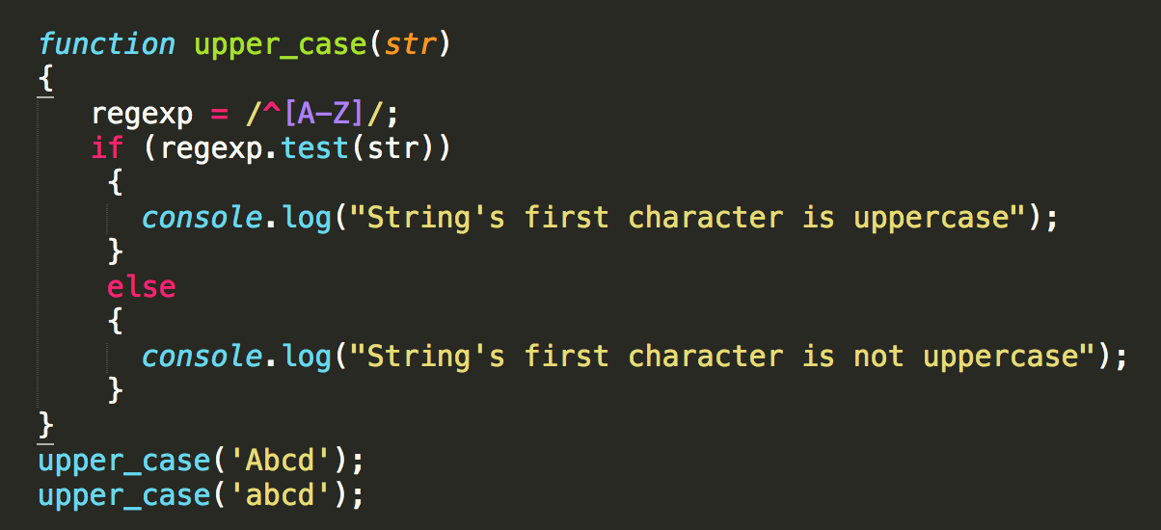

**Question 2 :** Write a JavaScript program to check a credit card number (Example : credit card number ( format 9999-9999-9999-9999 )

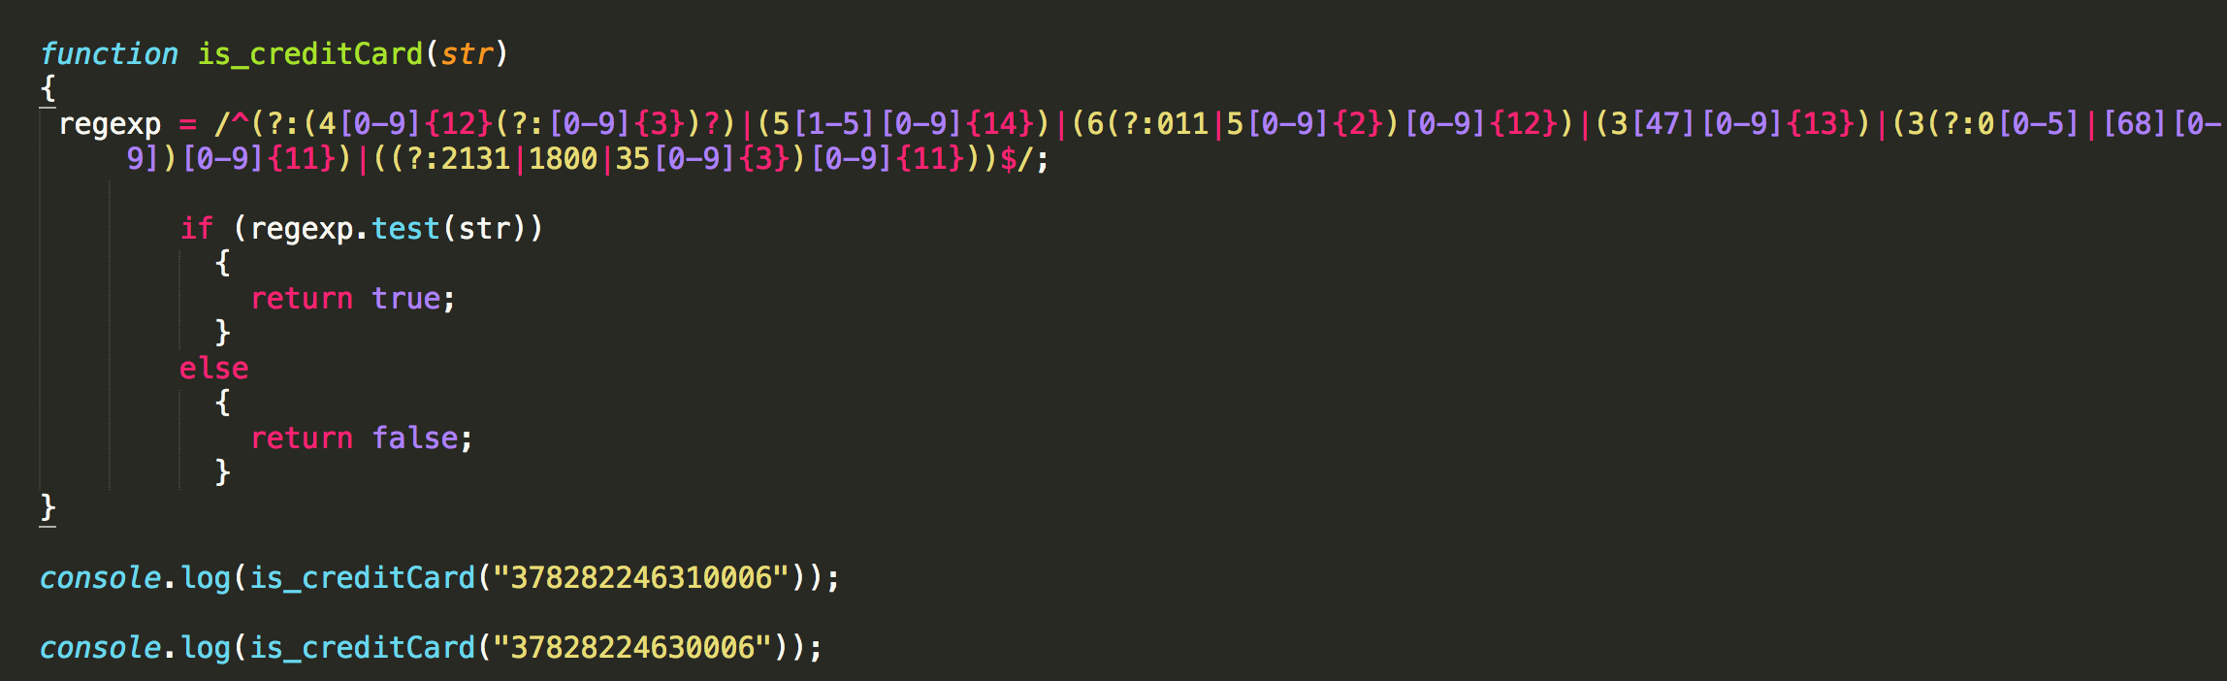

**Question 3 :** Write a pattern that matches e-mail addresses. The personal information part contains the following ASCII characters.

* Uppercase (A-Z) and lowercase (a-z) English letters.
* Digits (0-9).
* Characters ! # $ % & ' * + - / = ? ^ _ ` { | } ~
* Character . ( period, dot or fullstop) provided that it is not the first or last character and it will not come one after the other.

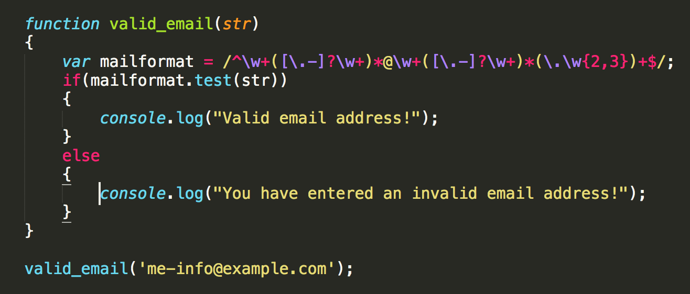

**Question 4 :** Write a JavaScript program to search a date within a string.

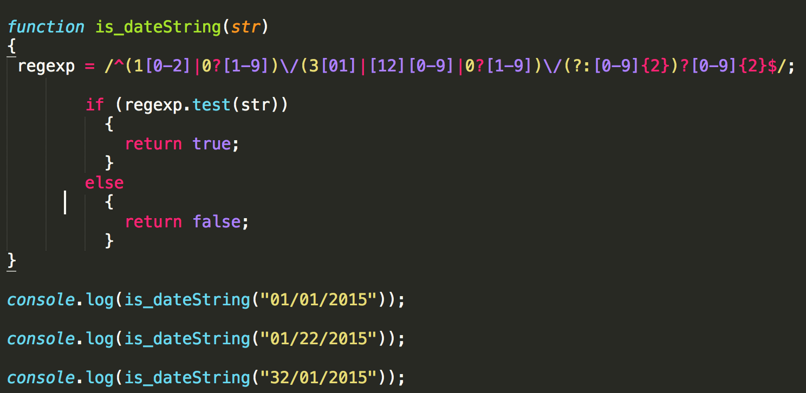

**Question 5 :** Write a JavaScript program that work as a trim function (string) using regular expression.

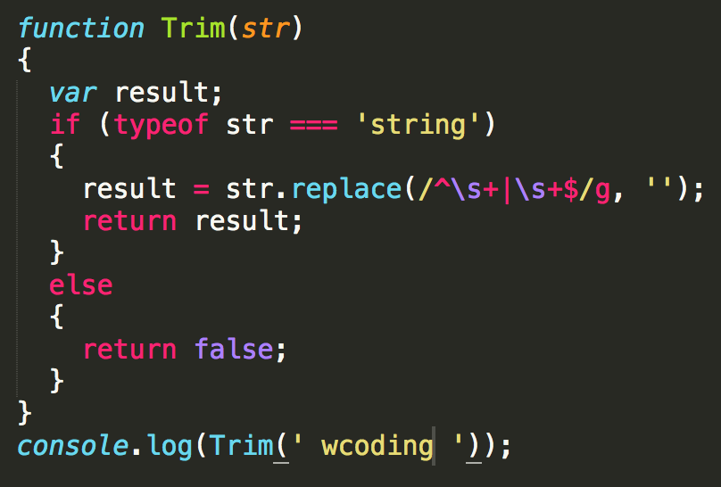

**question 6 :**  Write a JavaScript program to count number of words in string. *Note* :

- Remove white-space from start and end position.

- Convert 2 or more spaces to 1.

- Exclude newline with a start spacing.

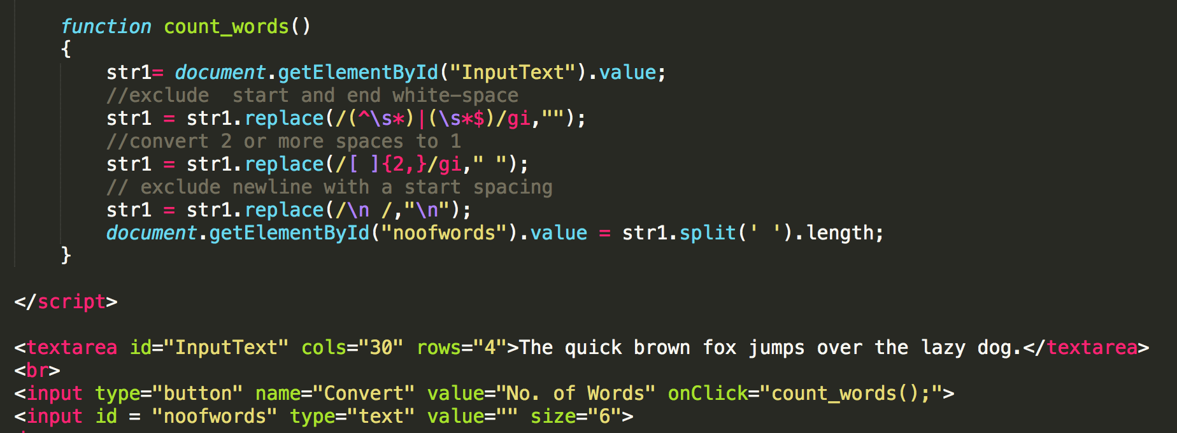

**question 7 :** Write a JavaScript function to check whether a given value is IP value or not.

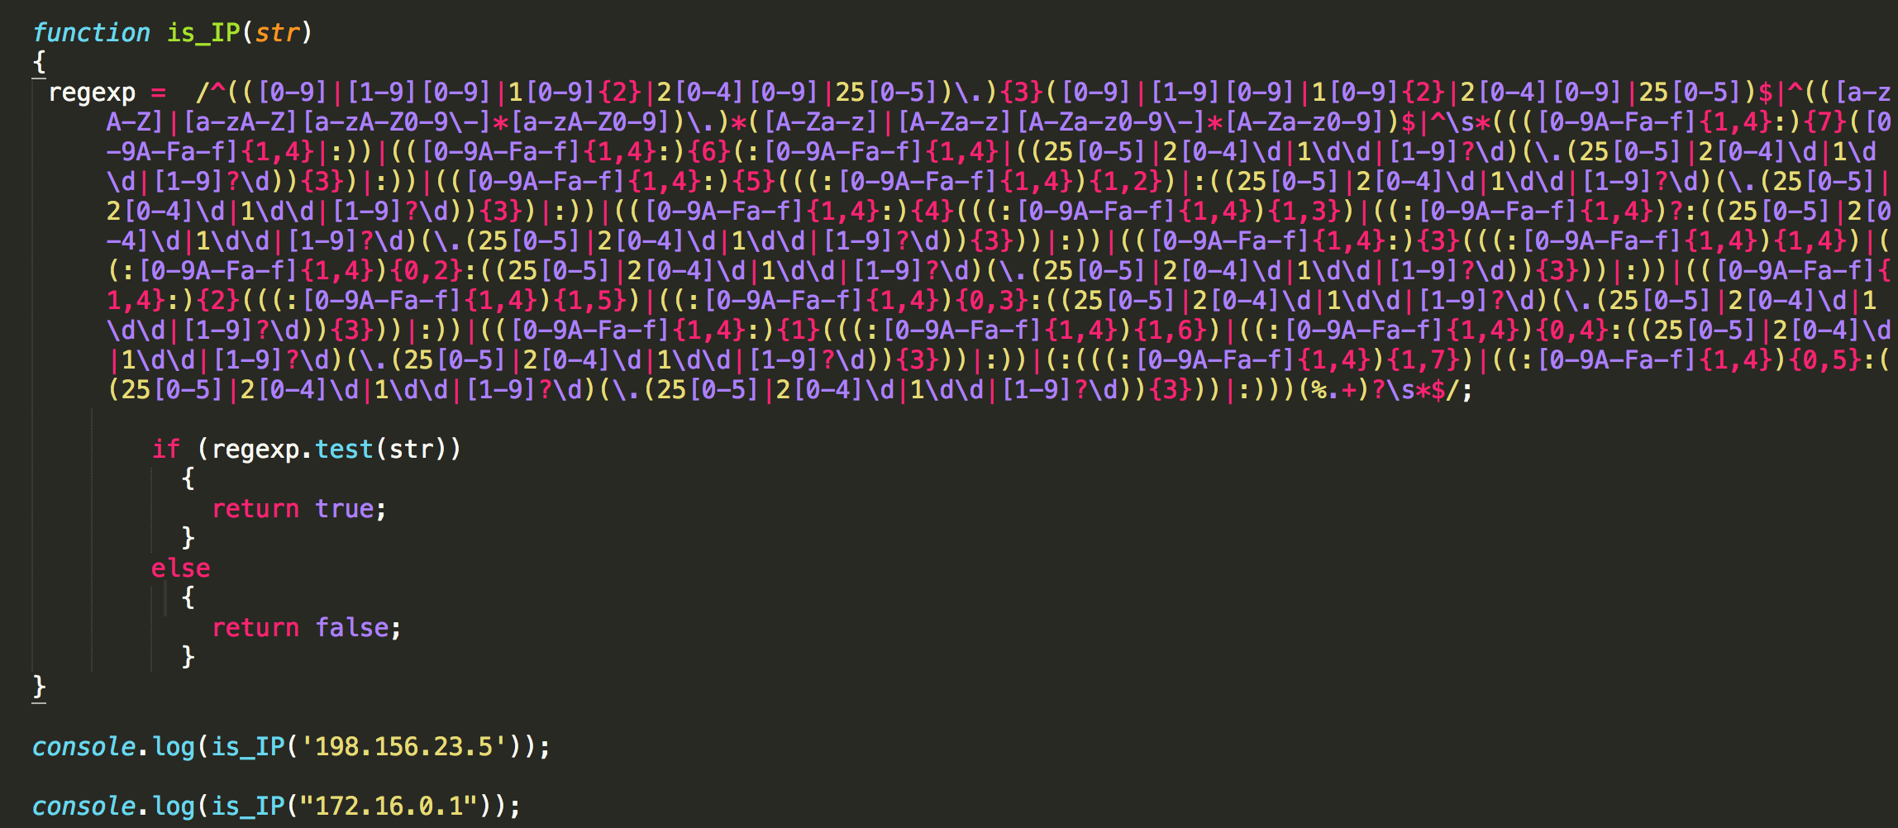

**question 8 :** Write a JavaScript function to count the number of vowels in a given string.

*Test Data* :

console.log(vowel_count('United States'));

Output :

5

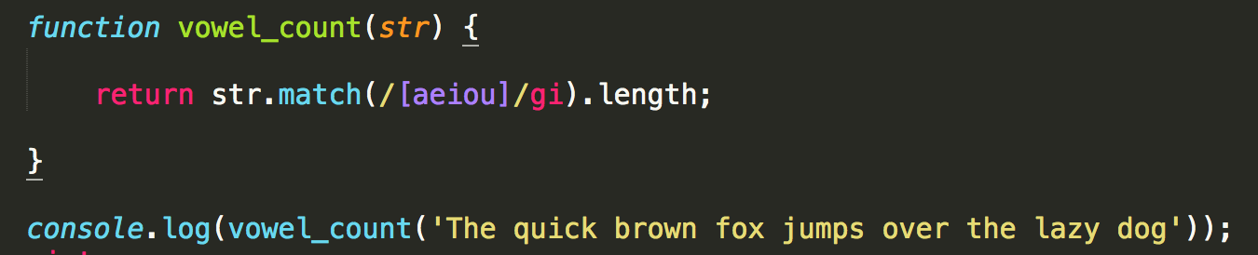

**question 9 :** Write a JavaScript function to check whether a given value is an valid url or not.

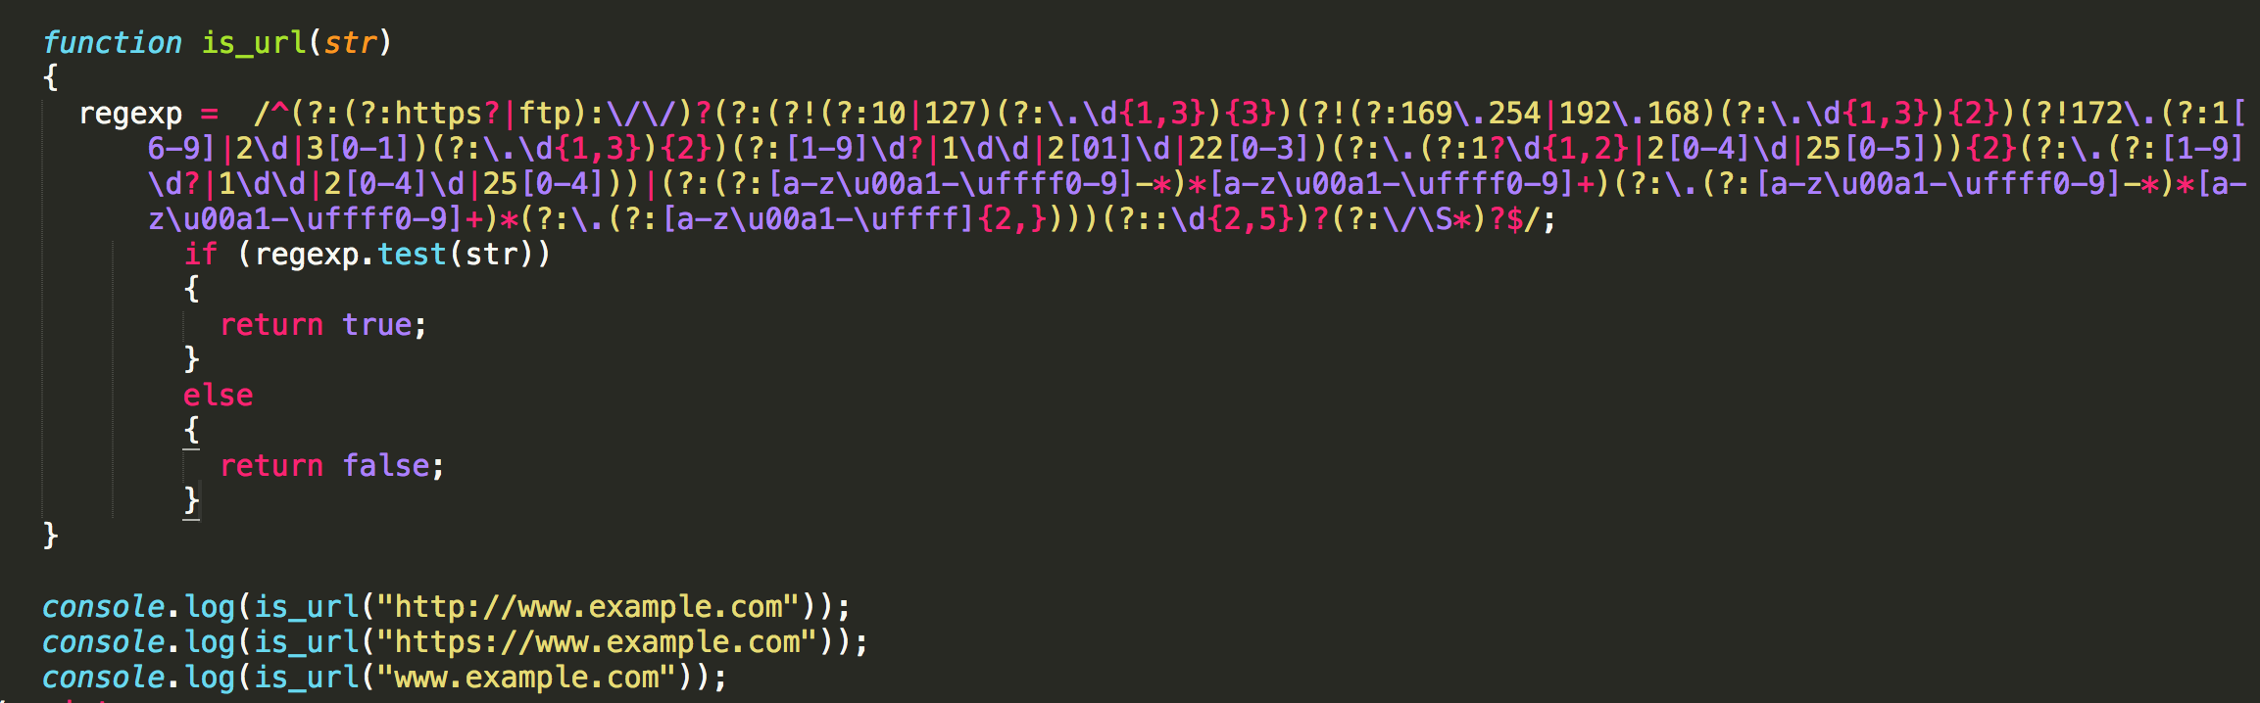

**question 10** : Write a JavaScript function to check whether a given value is alpha numeric or not.

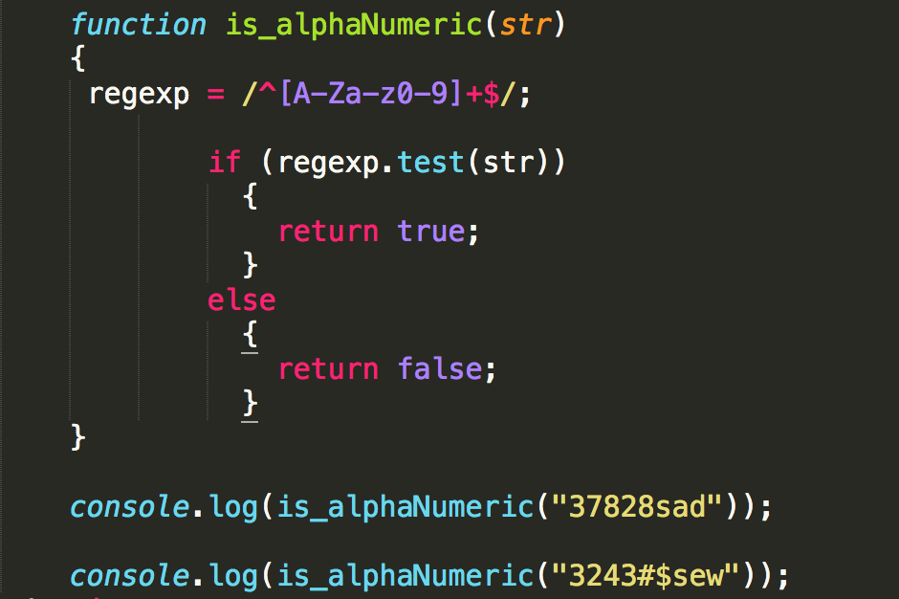

**question 11** : Write a JavaScript function to check whether a given value is time string or not.

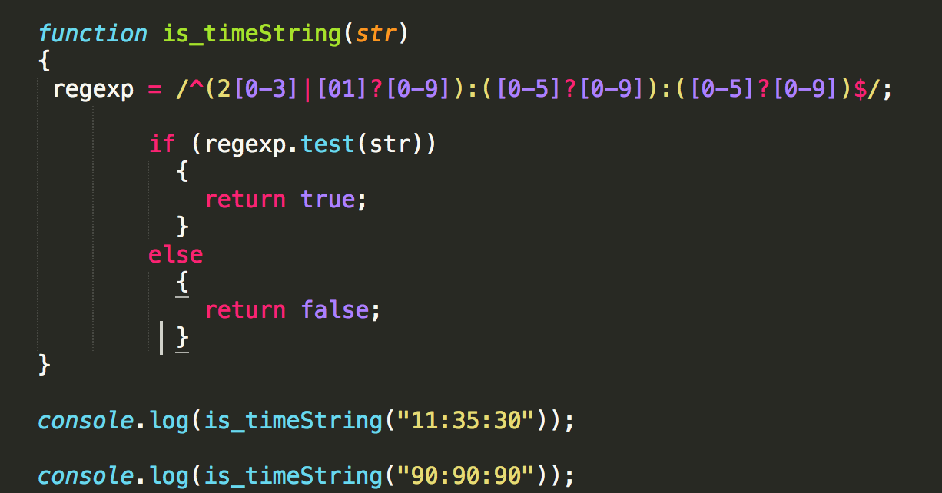

**question 12** : Write a JavaScript function to check whether a given value is US zip code or not.

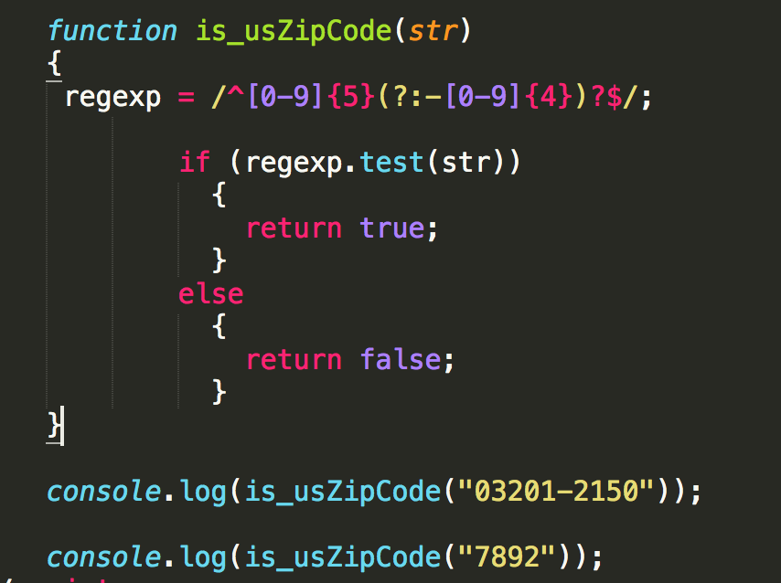

**question 13**: Write a JavaScript function to check whether a given value is UK Post Code or not.

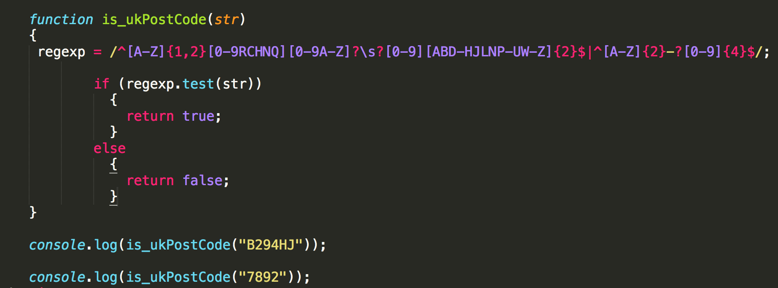

**question 14** : Write a JavaScript function to check whether a given value is Canada Post Code or not.

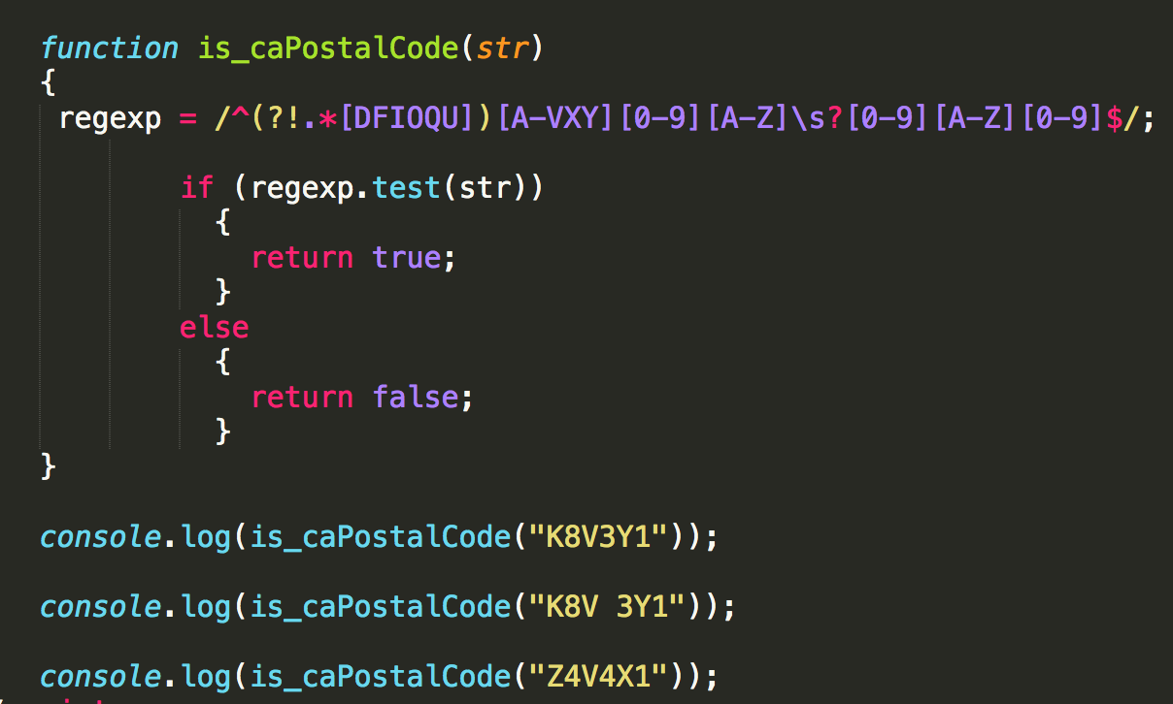

**question 15** : Write a JavaScript function to check whether a given value is a social security number or not.

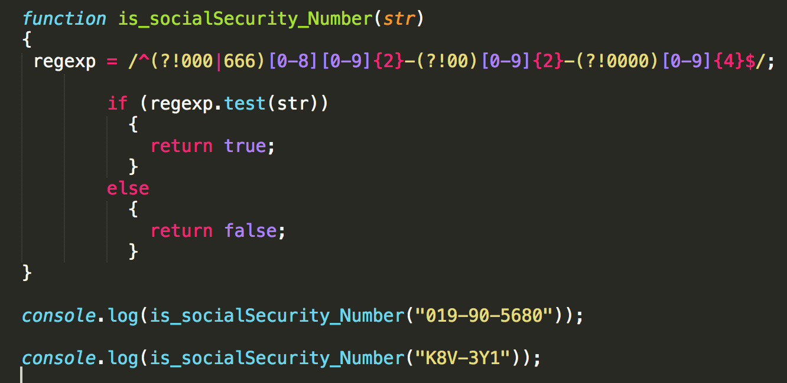

**question 16 :** Write a JavaScript function to check whether a given value is hexadecimal value or not.

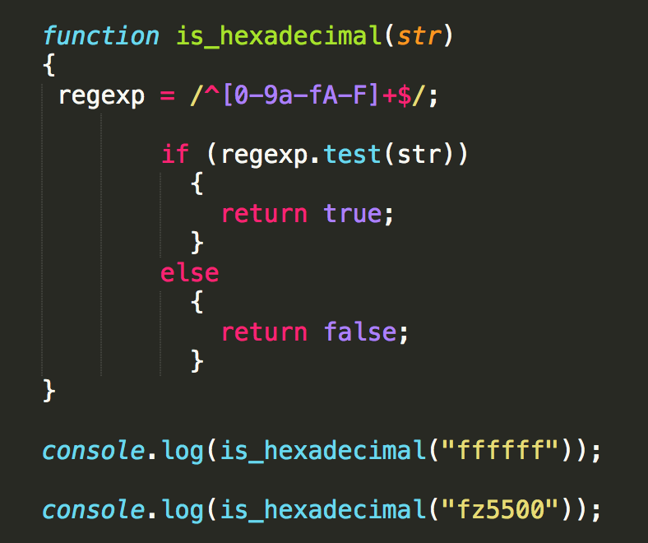

**question 17** : Write a JavaScript function to check whether a given value is hexcolor value or not.

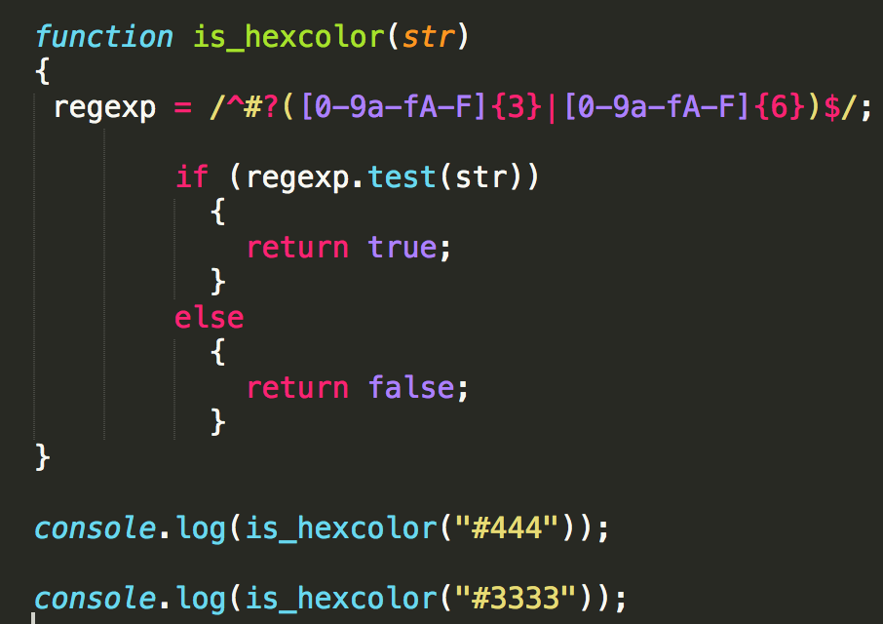

**question 18** : Write a JavaScript function to check whether a given value represents a domain or not.

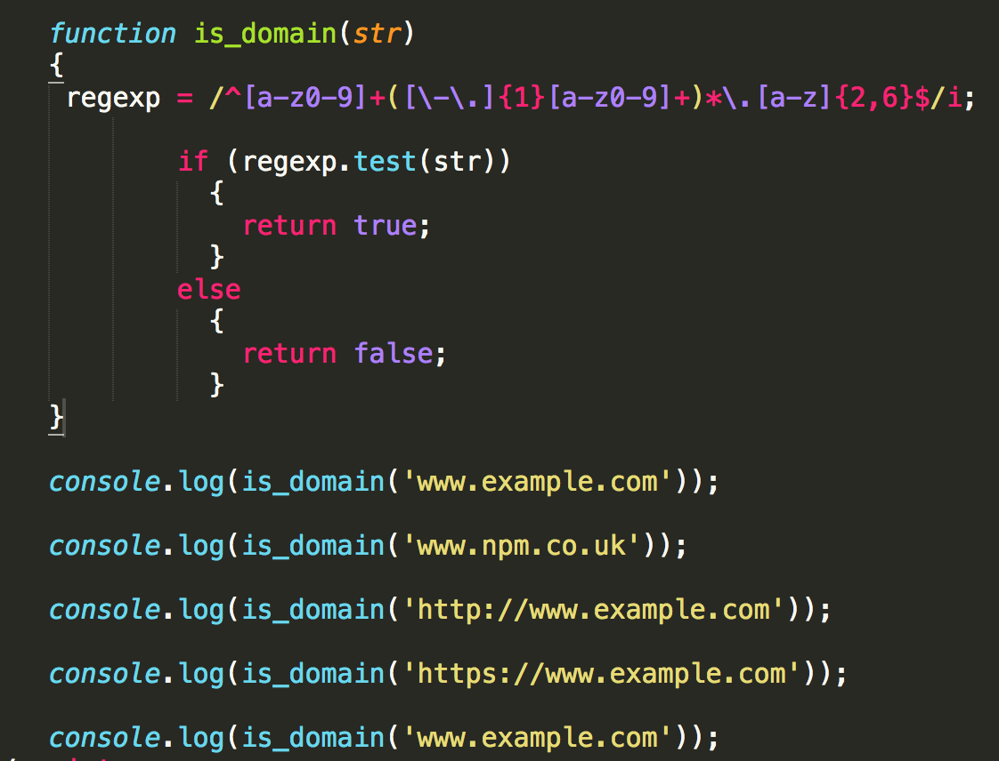

**question 19:** Write a JavaScript function to check whether a given value is html or not.

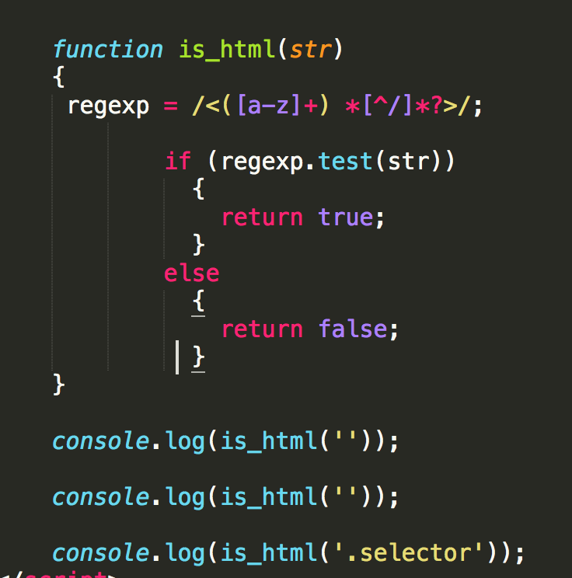

**question 20** : Write a JavaScript function to check a given value contains alpha, dash and underscore.

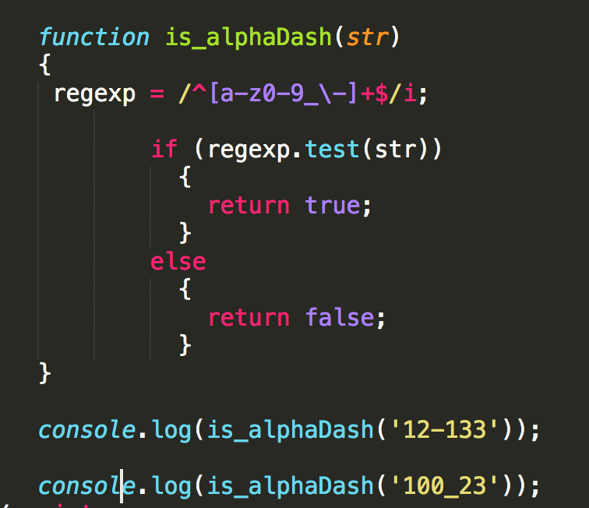

**question 21** : Write a JavaScript function to print an integer with commas as thousands separators.

Test Data :

console.log(thousands_separators(1000));

"1,000"

console.log(thousands_separators(10000.23));

"10,000.23"

console.log(thousands_separators(100000));

"100,000"

